NRICH Simultaneous Equations

Arithmagons
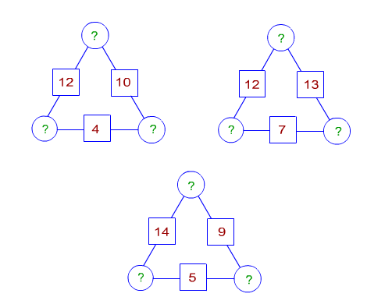

Letter Land
If
A | 5
B | 6
C | 0
D | 1
E | 7
F | 4
G | 3
H | 2
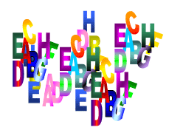
A + C = A
F x D = F
B - G = G
A + H = E
B / H = G
E - G = F
and A-H represent the numbers from 0 to 7
Find the values of A, B, C, D, E, F and H.
Symmetricality
Add up all 5 equations given below. What do you notice?
Solve the system and find the values of a , b , c , d and e .
b + c + d + e = 4
a + c + d + e = 5
a + b + d + e = 1
a + b + c + e = 2
a + b + c + d = 0
a = -1, b = -2, c = 2, d = 1 and e = 3

Whole Numbers Only
A student bought 17 pencils for £1.44. He paid 2 pence more for each coloured pencil than for each plain pencil. How many of each kind did he buy at what price?
Twenty Plants
Jasmine spends exactly £120 on three types of plants: poisoned ivy, deadly nightshade and triffids.
Poisoned ivy plants cost £2 each, deadly nightshade plants cost £9 each and triffids cost £12 each.
She buys twenty plants in total, including at least one of each type. How many triffids did she buy?

9 Poison Ivy, 10 nightshade, 1 trifid

CD Heaven
All CD Heaven stores were given the same number of a popular CD to sell for £24.
In their two week sale each store reduces the price of the CD by 25% and any further reductions are then left to the discretion of the store managers.

Towards the end of the two week sale one store still had 30 CDs left and the manager decided to try to clear the remainder by reducing the price by a further 1/3 but still did not manage to sell them all. The total sales for the CDs was £2010. If the store had managed to sell all its CDs by the end of the two week sale period it would have received £2370.
Another store sold the same number of CDs before and during the first two weeks of the sale as the first store but in reverse order (the number they sold for £24 was the same as the number sold in the two weeks of the sale by the first store and vice versa). At the end of the two weeks the shop manager decided to reduce the price of the CDs by a further 50% and managed to sell all the remaining 30 CDs making her total sales £2010.
How many CDs did the first store sell at each price?
50 CDs sold for £24
35 CDs sold for £35
15 CDs sold for £12.

